ASME (Victoria) STUDENT COMPOSER PROJECT (SCP)
An introduction.

What do teachers need when teaching composition?

The SCP aims to develop techniques and resources that capture students’ imaginations. This then leads to manageable strategies that can generate new expressions in class, small group and individual settings. Drama techniques and multimodal strategies are used to engage and focus students.

How is the project special?

The project aims to create structured and imaginative compositional strategies using the picture storybook titled Migaloo, The White Whale as a focus.

Mark Wilson, the author/illustrator, is directly involved in our journey.
This enables us to draw on Mark’s insights, understandings of the story and the processes he used to create the book. These ideas are then delivered directly to students.

Story background – based on a real character.

Migaloo, an extremely rare white whale, was born in the warm waters off the Queensland coast. Every year, she travels from Antarctica to Queensland. The journey is filled with many dangers and adventures.

Here is the book cover (Published by Hachette Publications)

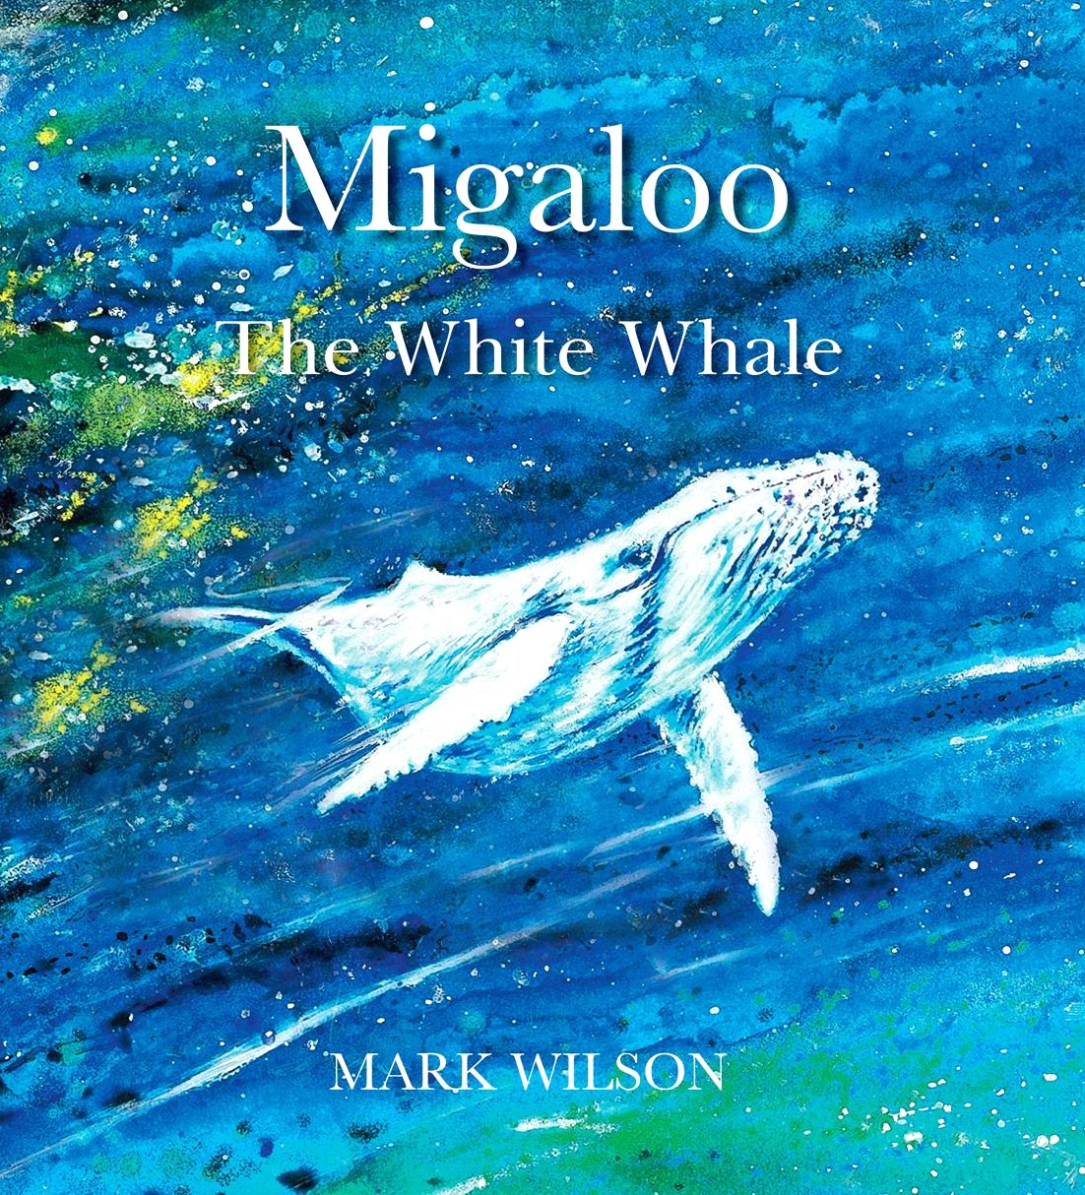

Resources developed during the project will include lesson ideas such as the one below, which will be transformed into video and audio support materials that can be used in the classroom.

A suggested approach to composition based on the
Victorian Curriculum F-10

Before we can create our music we need to experience the motion, the colours, the characters and the emotions of each story section.

For example, the first page shows a pod of whales playing in the warm shallow waters off the Queensland coast. There is a great deal of rich information on this page that provides clues that can develop pathways which will help to shape our compositions.

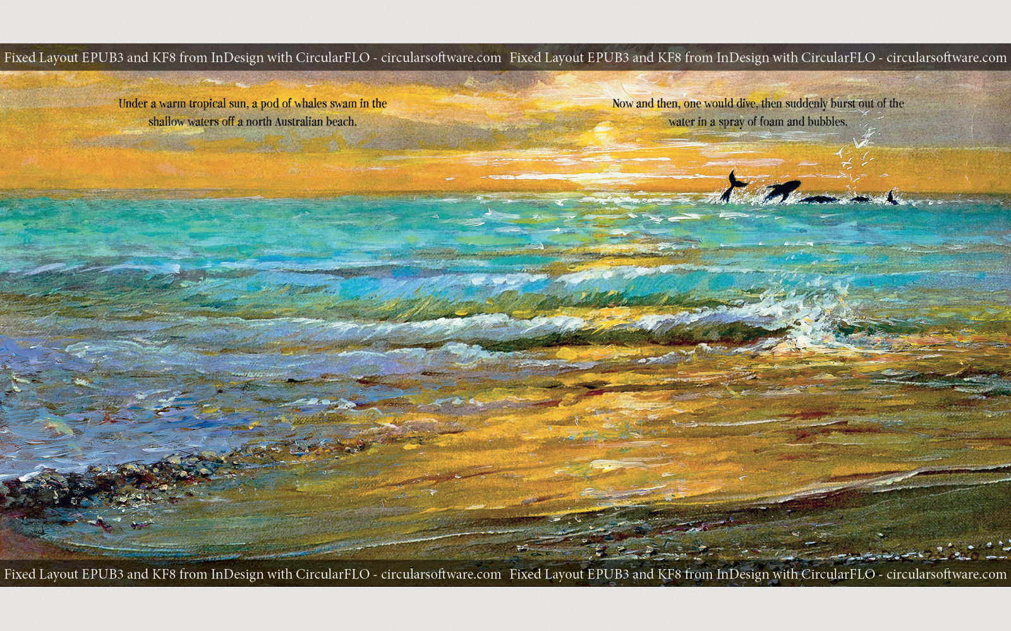

Story text

'Under a warm tropical sun, a pod of whales swam in the shallow waters off a north Australian beach. Now and then, one would dive, then suddenly burst out of the water in a spray of foam and bubbles.'

Possible Pathway 1 – Responding to the elements of the story

The setting - motion of the water

Firstly, we notice that a main feature of the picture is the water and that the whales are playing off in the distance. Now let’s find a way to generate student responses that nurture understandings and guide our music making.

Responding Activity 1 (A visual question which helps to form a pathway)

‘How is the water different in the picture below, compared to the open sea picture from the storybook above? ‘ Discuss.

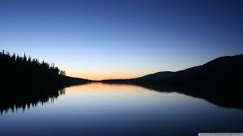

Responding Activity 2
(A movement activity, aiming to ‘internalize’ the feelings in the images before we compose.)

‘Now, close your eyes. Pretend your hands are gliding over the water of the lake.’

Do any of these words describe the water on the lake?

bouncy flat crashing smooth still jumping angry relaxing

‘Now open your eyes, look at the open sea picture.
How is the water different in this picture?’

‘Close your eyes, pretend your hands are like a leaf on the ocean.
How will they be moving? Show the motion of the water in this picture.
Do any of these words describe the movement of the ocean?
Can you create more descriptive words?’

ferocious rippling rhythmical peaceful crying contented

Creative activity 1
(Drawing on observations and understandings from the responding questions above)

Below are some possible sound sources we can use:

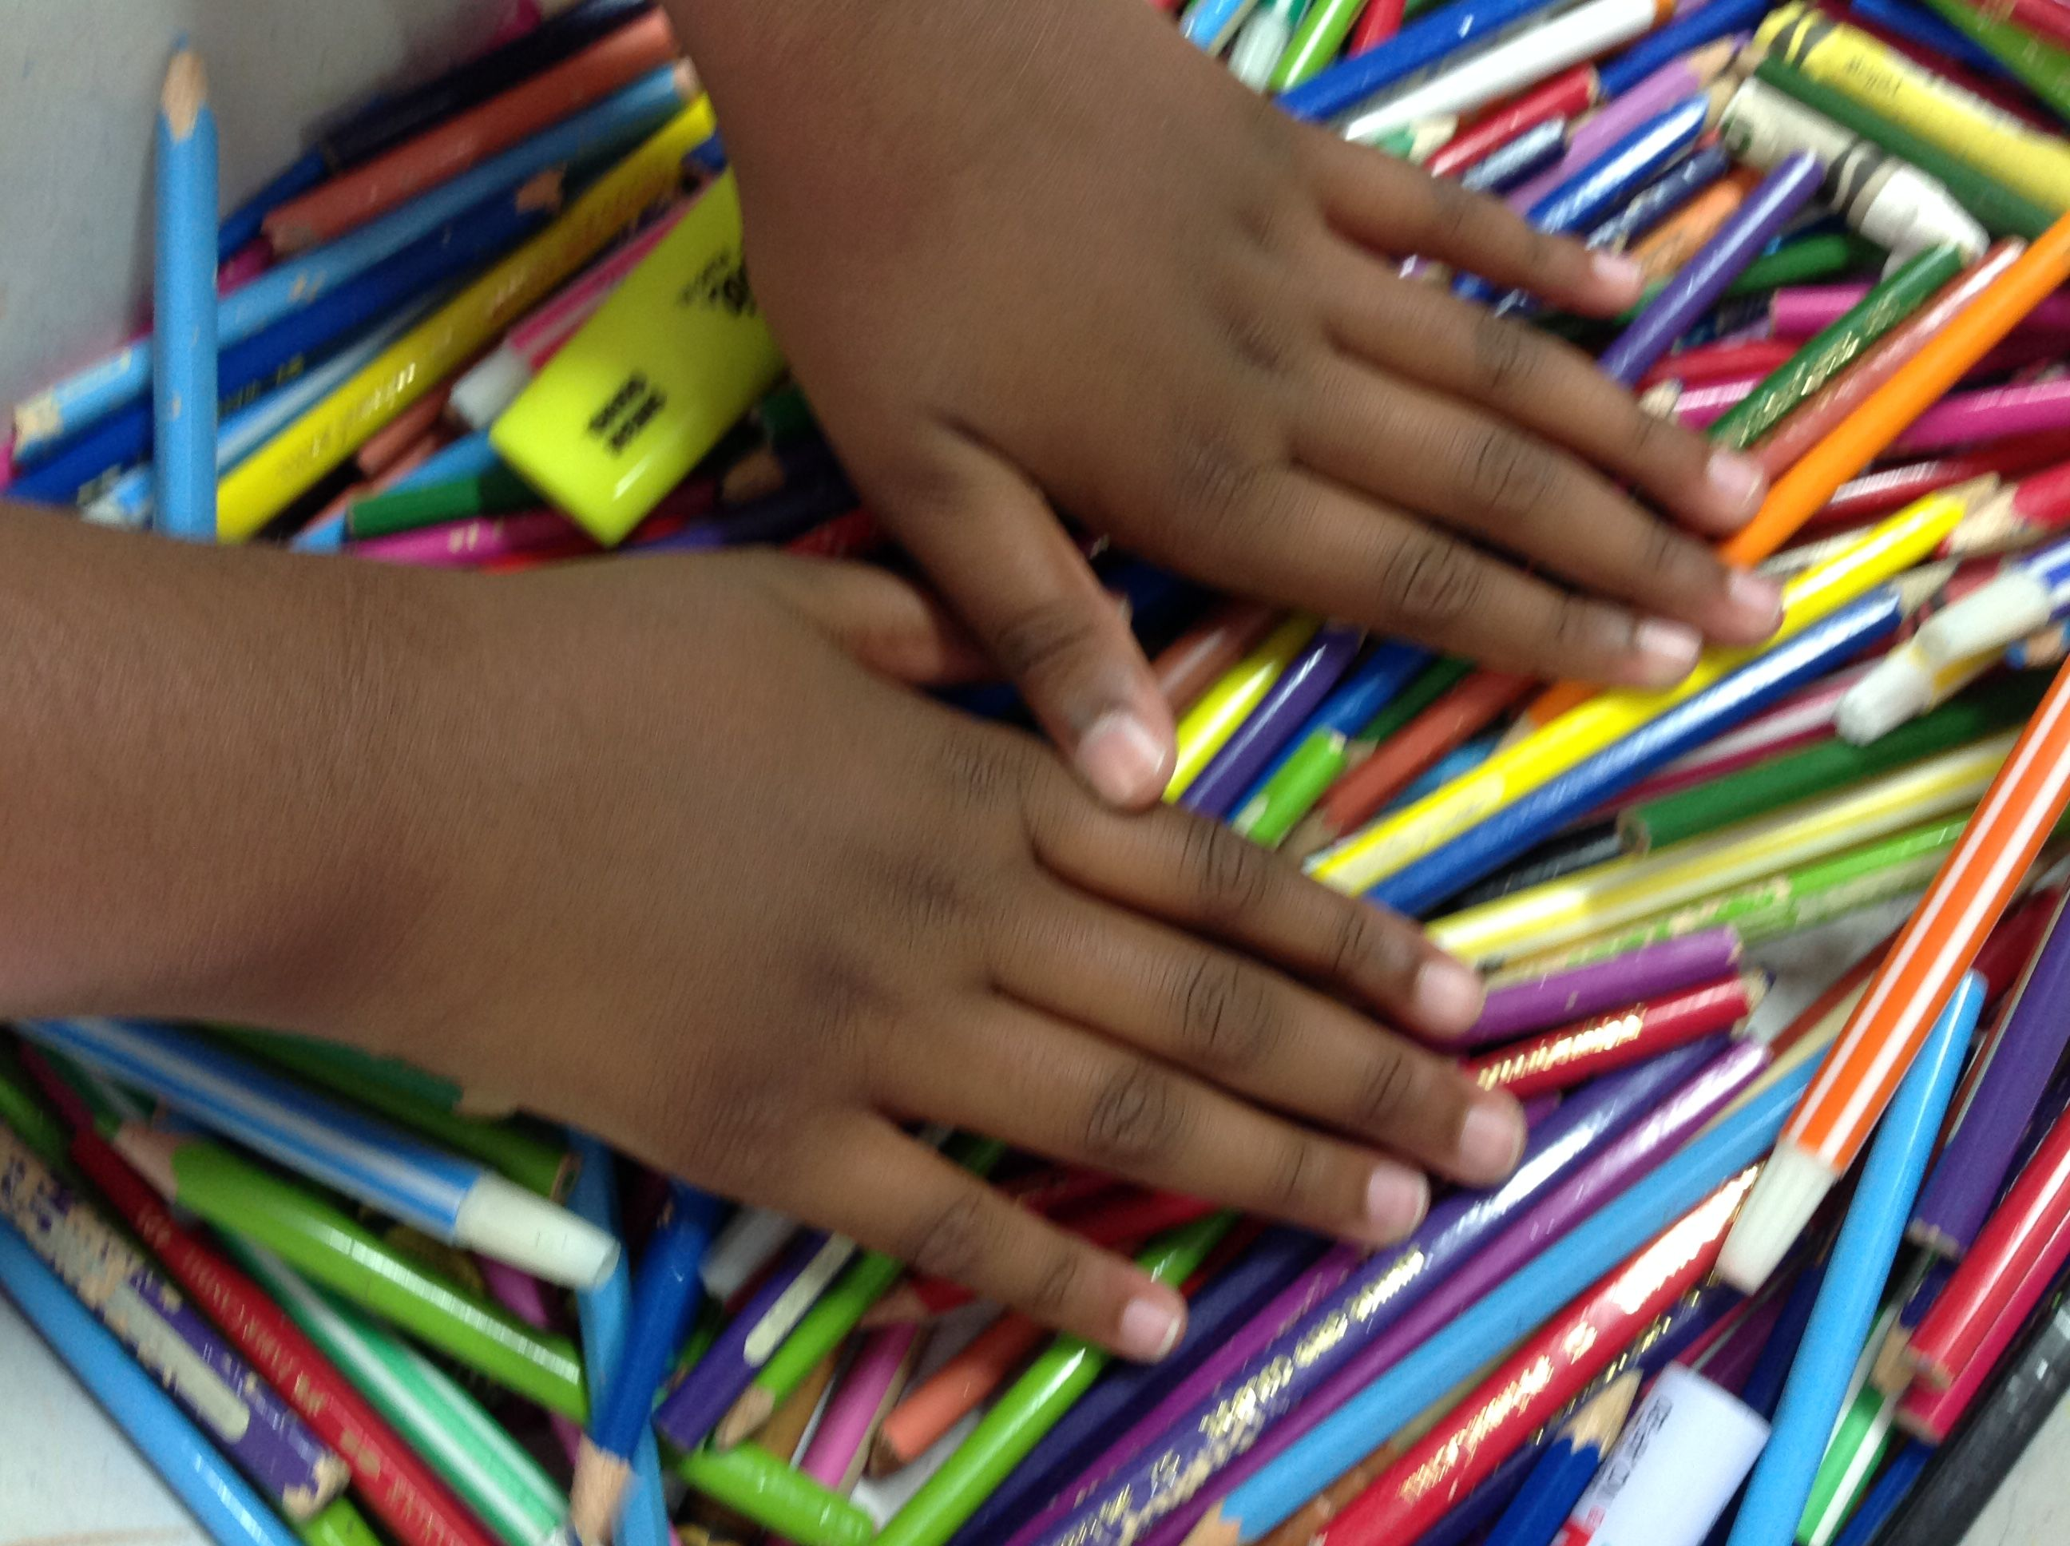 | 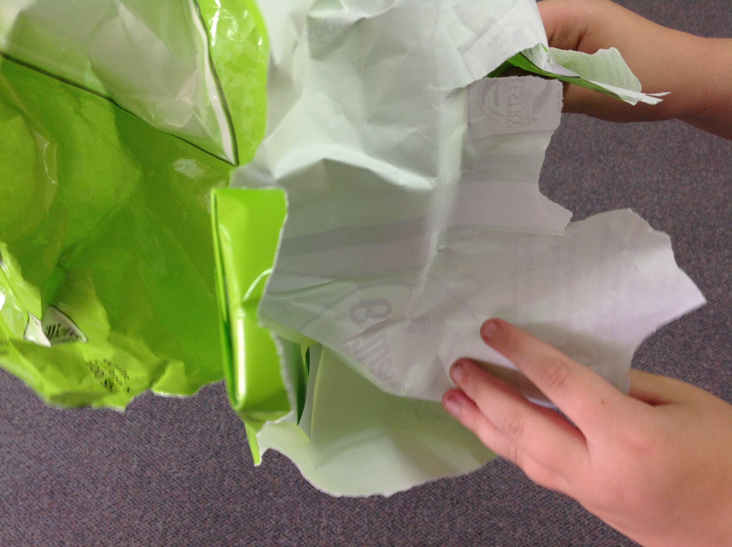 | 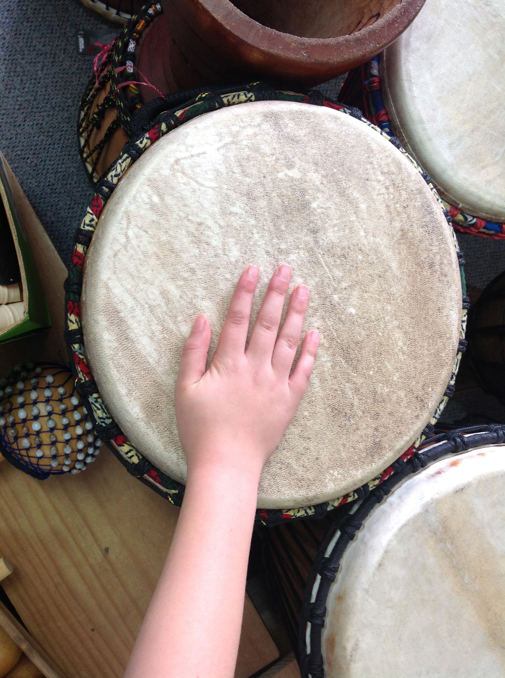 | 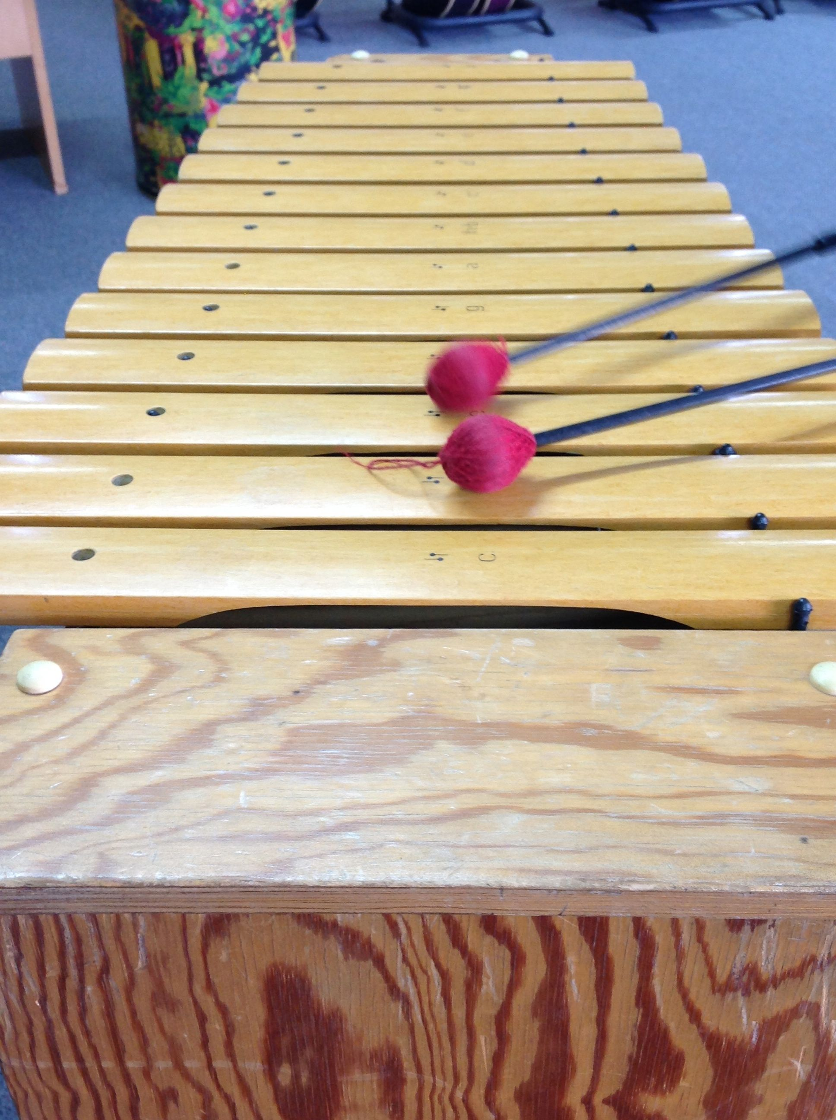
Rustling and dropping pencils | Scrunching and rubbing paper | Rubbing and tapping a drum | Xylophone glissando

Create some sounds using the ideas above or your own instruments.

We may observe that the waves are small, but they are still rhythmical.
The waves may create a peaceful sense of motion. That means one layer of the music we create may make us feel peaceful and contented. If this is so, how can we create this ‘energy level’ in the music?

Pathway 2. The movement of the whales
(‘Internalizing’ the motion of the whales.)

In this layer, we will think about the motion of the whales in the background,

- rolling and gliding underwater

- diving up out of the water, spraying foam and bubbles

We can use hand movements and also create whole body statues of:

- a whale gliding underwater
- a whale diving out of the water

Ask students to make a statue of a whale heading towards the bottom of the ocean – hold.
Now ask students to show a statue of a whale diving up to the surface – what expression is on the whale’s face?
Now show a statue of a whale splashing down and rolling on the water.

Repeat the three statues, in order - 5 seconds for each statue, in silence.

Repeat the action above, accompanying with an instrument.

Now add more instruments. Combine these sounds with the wave sounds already made.

All this may happen before we even think about the colours used and before we have discussed melody or harmony.

Further Questions and Directions

How can we draw the music in graphic notation?
This helps us to organise and communicate our ideas.

How many seconds of wave music should we have before we introduce the whales?

We notice that the colours used are warm. How will this affect the kinds of sounds we choose to use?
Will the rhythms be bumpy or smooth?
Can we combine bumpy and smooth rhythms to create the effect we want?
We can ask ourselves whether we will use high notes or low notes.
We can ask whether we want to use chords or a melody or even both together.

There are thousands of ways to learn to compose music. In a classroom setting we need a balanced combination of structure and freedom. A sensible balance will promote imagination and expression. We can also learn to 'talk about music' in ways which help us to compose.

How is the music breathing?
What if I played the same pattern five notes higher?
What if we ………..???

When we share ideas we can learn from each other. This is great fun as often one person's idea sparks a new and different idea from another person, adding one great idea after another. Our composition soon begins to take shape which is interesting and exciting. And soon we have our own composition!

Visit the following website for more ideas in relation to composing music for Migaloo: The White Whale:

https://sites.google.com/view/scpasme/home

